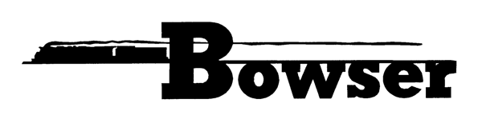
PO Box 322
Montoursville PA 17754
570-368-2379
570-368-5046 Fax
www.bowser-trains.com bowser@bowser-trains.com

New From Bowser – HO Freight Car Kits
In Stock January 2018

60249 | H21 PRR Circle Key #676248 | $17.95
60250 | H21 PRR Circle Key #676251 | $17.95
60251 | H21 PRR Circle Key #676256 | $17.95
60252 | GLa PRR Lines #141262 | $17.95
60253 | GLa PRR Lines #141267 | $17.95
60254 | GLa PRR Lines #141244 | $17.95
60255 | GLa Keystone Coal #1714 | $17.95
60256 | GLa Keystone Coal #1720 | $17.95
60257 | GLa Keystone Coal #1724 | $17.95
60258 | GLa Jamison Coal #658 | $17.95
60259 | GLa Jamison Coal #663 | $17.95
60260 | GLa Jamison Coal #667 | $17.95
60261 | GLa Blue Coal, Reading #80003 | $17.95
60262 | GLa Blue Coal, Reading #80016 | $17.95
60263 | GLa Blue Coal, Reading #80019 | $17.95
60266 | GLa CI&S (NYC) #185003 | $17.95
60267 | GLa CI&S (NYC) #185006 | $17.95
60268 | GLa CI&S (NYC) #185008 | $17.95
60269 | GLa Western Maryland #8010 | $17.95
60270 | GLa Western Maryland #8013 | $17.95
60271 | GLa Western Maryland #8017 | $17.95

