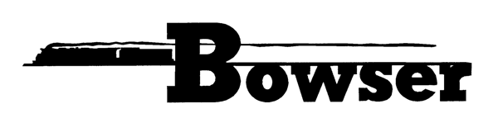 4/27/2015
PO Box 322
Montoursville PA 17754
570-368-2379
570-368-5046 Fax
www.bowser-trains.com bowser@bowser-trains.com

New From Bowser – HO Executive Line H21 & H22 Hopper Cars
Pre orders Due 6/12/15 Delivery Expected November, 2015
41194 | H21 Bertha Coal w/Clamshell Doors #1026 | $25.95
41195 | H21 Bertha Coal w/Clamshell Doors #1027 | $25.95
41196 | H21 Bertha Coal w/Clamshell Doors #1028 | $25.95
41197 | H21 Bethlehem Mines w/Clamshell Doors #6225 | $25.95
41198 | H21 Bethlehem Mines w/Clamshell Doors #6232 | $25.95
41199 | H21 Bethlehem Mines w/Clamshell Doors #6236 | $25.95
41200 | H21 Erie w/Clamshell Doors #55016 | $25.95
41201 | H21 Erie w/Clamshell Doors #55026 | $25.95
41202 | H21 Erie w/Clamshell Doors #55046 | $25.95
41203 | H21a PRR Circle Keystone w/Clamshell Doors #407004 | $25.95
41204 | H21a PRR Circle Keystone w/Clamshell Doors #407014 | $25.95
41205 | H21a PRR Circle Keystone w/Clamshell Doors #407044 | $25.95
41206 | H21a PRR Circle Keystone #186323 | $25.95
41207 | H21a PRR Circle Keystone #186324 | $25.95
41208 | H21a PRR Circle Keystone #186325 | $25.95
41209 | H21a PRR Circle Keystone #186424 | $25.95
41210 | H21a PRR Circle Keystone #186425 | $25.95
41211 | H21a PRR Circle Keystone #186426 | $25.95
41212 | H21a PRR Shadow Keystone #923241 | $25.95
41213 | H21a PRR Shadow Keystone #923251 | $25.95
41214 | H21a PRR Shadow Keystone #923261 | $25.95
41215 | H22 PRR w/Clamshell Doors #406297 | $25.95
41216 | H22 PRR w/Clamshell Doors #406298 | $25.95
41217 | H22 PRR w/Clamshell Doors #406299 | $25.95
41218 | H22 PRR Circle Keystone w/Clamshell Doors #406102 | $25.95
41219 | H22 PRR Circle Keystone w/Clamshell Doors #406112 | $25.95
41220 | H22 PRR Circle Keystone w/Clamshell Doors #406132 | $25.95
41221 | H22 PRR Lines w/Clamshell Doors #912705 | $25.95
41222 | H22 PRR Lines w/Clamshell Doors #912715 | $25.95
41223 | H22 PRR Lines w/Clamshell Doors #912725 | $25.95
41224 | H22a PRR Circle Keystone Coke Car #904702 | $25.95
41225 | H22a PRR Circle Keystone Coke Car #904703 | $25.95
41226 | H22a PRR Circle Keystone Coke Car #904704 | $25.95

