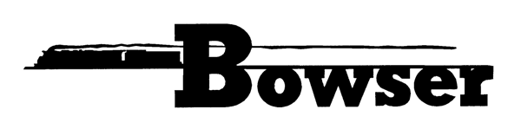
PO Box 322
Montoursville PA 17754
570-368-2379
570-368-5046 Fax
www.bowser-trains.com bowser@bowser-trains.com

HO RTR N8 Caboose
Pre orders Due 8/11/23 Delivery Expected Fall 2024

#43406 | Conrail #23316 Rpkd 6-78 | $32.95
#43407 | Conrail #23342 Rpkd 6-78 | $32.95
#43408 | Penn Central #23309 Rpkd 5-72 | $32.95
#43409 | Penn Central #23318 Rpkd 5-72 | $32.95
#43410 | PRR Circle Keystone Central Region #478025 Rpkd 5-51 | $32.95
#43411 | PRR Circle Keystone Central Region #478046 Rpkd 5-51 | $32.95
#43412 | PRR Cir. Key. West. Reg. w/Trainphone #478122 Rpkd 5-51 | $39.95
#43413 | PRR Cir. Key. West. Reg. w/Trainphone #478142 Rpkd 5-51 | $39.95
#43414 | PRR Plain Keystone w/Trainphone #478203 Rpkd 3-62 | $39.95
#43415 | PRR Plain Keystone w/Trainphone #478213 Rpkd 3-62 | $39.95
#43416 | PRR Sh. Key. Lake Reg. w/Trainphone #478140 Rpkd 1-56 | $39.95
#43417 | PRR Sh. Key. Lake Reg. w/Trainphone #478162 Rpkd 1-56 | $39.95
#43418 | PRR Sh. Key. Pitts. Reg. w/Trainphone #478110 Rpkd 5-56 | $39.95
#43419 | PRR Sh. Key. Pitts. Reg. w/Trainphone #478158 Rpkd 5-56 | $39.95
#43420 | PRR Shadow Key. Philadelphia Region #478042 Rpkd 10-59 | $32.95
#43421 | PRR Shadow Key. Philadelphia Region #478074 Rpkd 10-59 | $32.95
#43422 | PRR Circle Key. New York Region #478043 Rpkd 5-51 | $32.95
#43423 | PRR Circle Key. New York Region #478072 Rpkd 5-51 | $32.95
#43424 | PRR Circle Keystone Eastern Region #478091 Rpkd 2-53 | $32.95
#43425 | PRR Circle Keystone Eastern Region #478094 Rpkd 2-53 | $32.95
#43426 | PRR Cir. Key. Cen. Reg. w/Trainphone #478103 Rpkd 11-53 | $39.95
#43427 | PRR Cir. Key. Cen. Reg. w/Trainphone #478116 Rpkd 11-53 | $39.95

